train.py

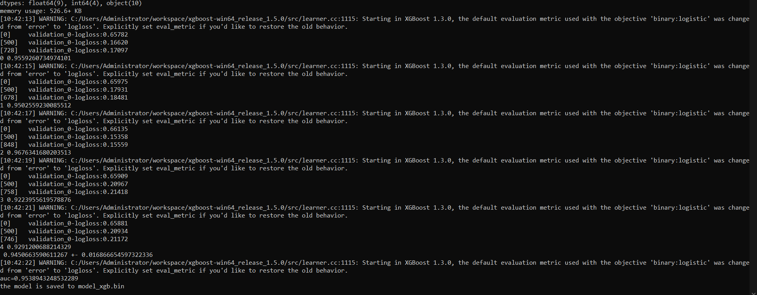

Prediction on Jupyter Notebook

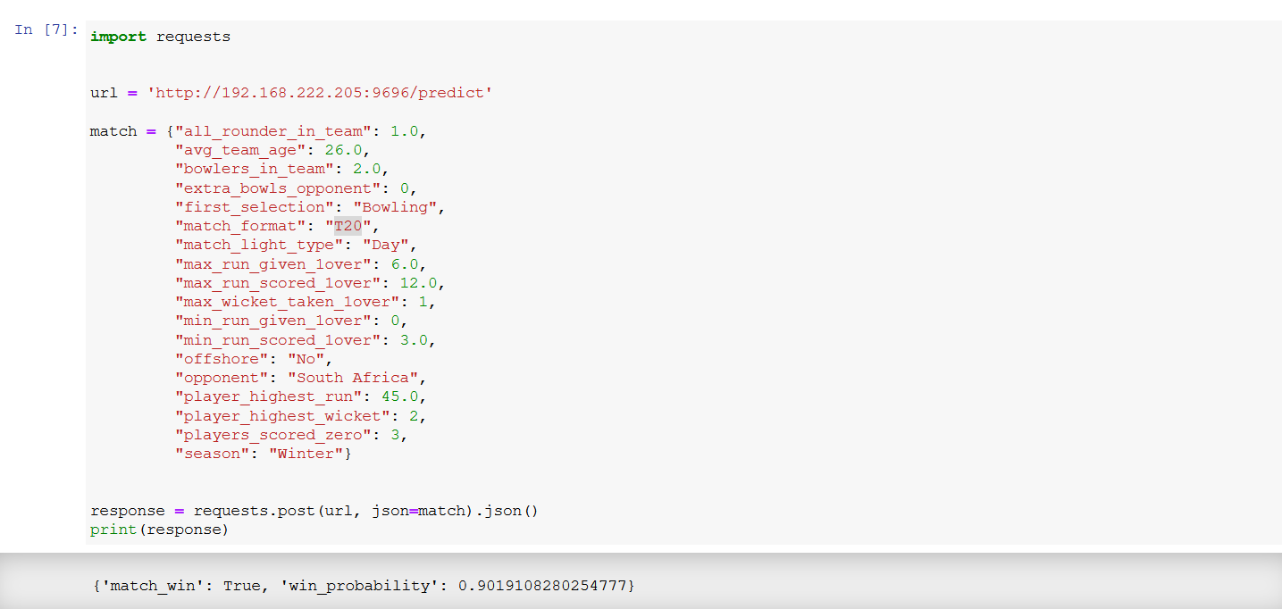

Using ``Waitress`` for deployment



Checked the results by running the predict.py file in anaconda prompt

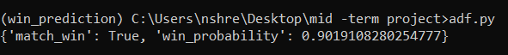

Clone the Repository

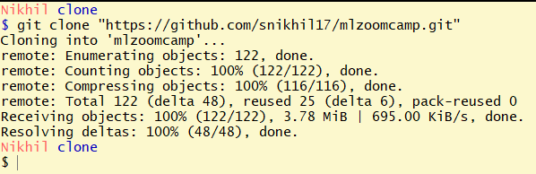

Loaded the Model using train_rf.py file

